OUTPUT

1. When we run the project, following is the output in console of Eclipse IDE :

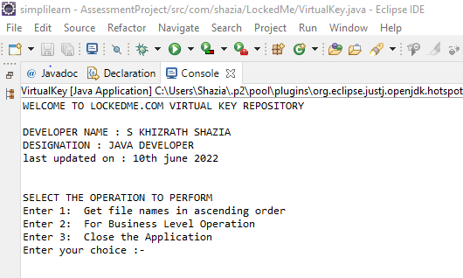

In Output screen contains

a)Application welcome page

b)Developer details

c)Select options for User Interaction/User Interface

1. When user selects “1” , First option- Here we can see that the files are arranged in ascending order based on alphabetical order along with case sensitivity with upper case letter arranged 1st then lower case as per ascii values.

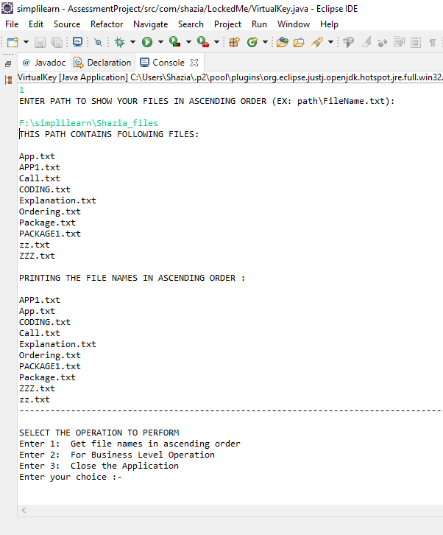 returns the file names in Ascending order.

1. When user select ”2” , it will direct the user to choose any Business Level Operations, where add , delete, search operations can be performed .
2. When user selects add function by entering “1” , they will be asked to enter a file name ,doing so will create a new file in existing default directory

BEFORE ADDING FILE

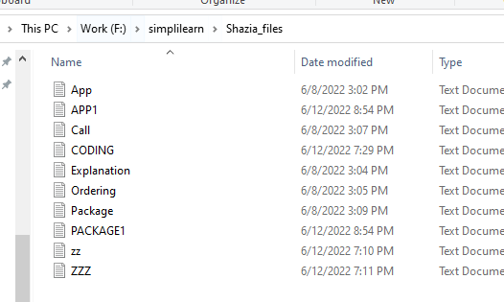

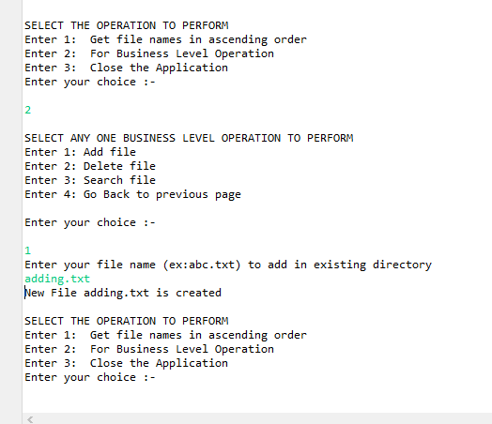

AFTER ADDING FILE

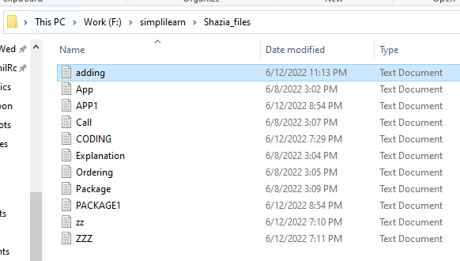

1. When user selects delete function by entering “2” , they will be asked to enter a file name ,doing so will delete the existing file and if file is unavailable they will be prompted with FNF.

BEFORE DELETING FILE



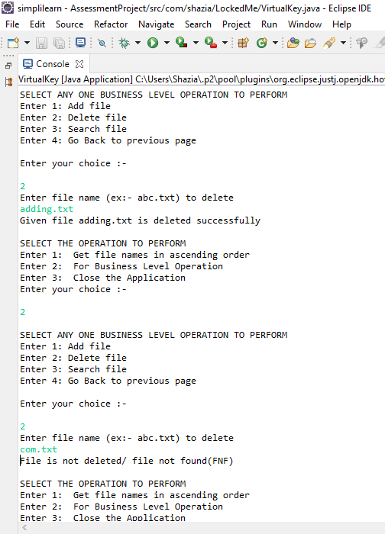

AFTER DELETING FILE



1. When user selects search function by entering “3” , they will be asked to enter a file name ,doing so will search for the existing file and if file is unavailable they will be prompted with FNF.

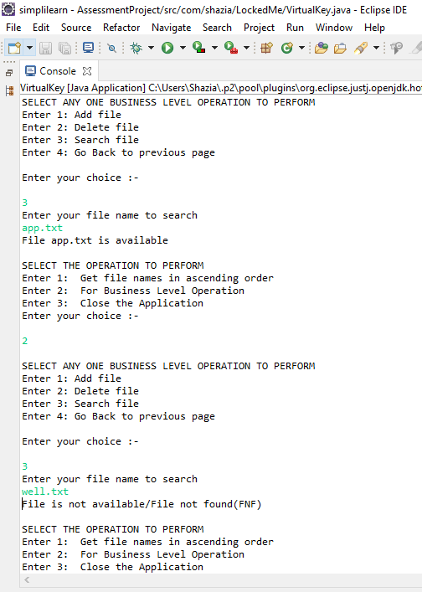

1. When user selects to go back to general operations can choose “4” .

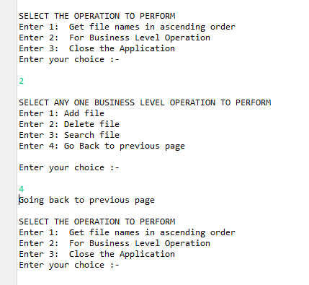

1. When User selects “3”, application will close. And when user enters invalid input it’ll be prompted to enter valid input.

